Development of Advanced AuSn Alloy Plating Technology for Semiconductor Application

Zhang Ling, Ng Seow Ching, Li Zheng, Fang Shu Nong
Singapore Epson Industrial Pte Ltd
Singapore
seowching.ng@sep.epson.com.sg, shunong.fang@sep.epson.com.sg
Tennyson Nguty, Emiel de Bruin, An Xiao, Henk Thoonen
NXP Semiconductors Gerstweg 2, 6534 AE
Nijmegen, The Netherlands
tennyson.nguty@nxp.com, emiel.de.bruin@nxp.com, an.xiao@nxp.com, henk.thoonen@nxp.com

Abstract—Comparing with solder preforms, pastes and wafer backside evaporation, electroplating is a cost effective alternative. Electroplating process for depositing AuSn alloys onto metallized ceramic and semiconductor substrates, from a single solution has been developed.
The stability of electroplating solution along with the effect of current density was studied. In addition, deposition uniformity could be improved by solution circulation.
In this paper, a range of methodologies including SEM-EDX, GD, XRD, Laser microscope, and DSC were used to characterize AuSn Morphology, composition, uniformity, crystal structure, roughness and melting point properties. Composition with Au80Sn20 corresponds to both Au5Sn and AuSn phase respectively, which resulted in the eutectic composition of AuSn alloy. Stability of AuSn as a backside metal (BSM) for eutectic die attach with respect to environmental test (temperature cycling) is presented.

Keywords—AuSn alloy, electroplating, die attach, stability semiconductor

Introduction
Die attach is considered as a key backend assembly processes in semiconductor packaging. Depending on the application area, various die attach materials can be used. In the recent years, AuSn (80/20 wt%) solder alloy has gained more and more attention due to its excellent thermal/reliability performance [1,2] and high melting temperature [3]etc.
The phase diagram presented in Figure 1 was compiled by Okamoto [4] and Liu et al.[5]. At the eutectic composition, intermetallic AuSn-δ phase and Au5Sn- ζ phase formed, and at temperature below 190˚C, the ζ’-phase is formed. This is a stable intermetallic phase with the composition Au5Sn.
During the soldering process the eutectic melt dissolves gold and forms ζ-phase. This phase is stable up to 519˚C, has good mechanical properties, a decreased thermal resistance and excellent reliability [6, 7]. Due to lead free feature, AuSn alloy gradually becomes one of the best materials for soldering in flip chip, optoelectronic devices and components packaging, and die-attachment for ASIC (Application Specific Integrated Circuit) [2]. AuSn solder as a die attach material also provides an additional process benefit - it is compatible for flux-less soldering. This means, components can be easily attached by thermo-compression.
However, AuSn die attach is not widely used because of high cost and difficult to manufacture. In this study, we have developed a reliable and commercially available cost effective wafer plating process for AuSn die attach.

Fig. 1 Au-Sn phase diagram [4]
AuSn alloy plating layer can provide equivalent effect of current time-consuming alternative such as paste, preform and sputtered and evaporated film with substance cost down by providing less material and high material availability. Above all, AuSn electroplating has advantage of accurate positioning, wafer level bump and can be applied to complex graphics substrate [8]. Our AuSn plating technology can be applied on any type of semiconductor wafers like Si, sapphire and GaN based. Depending on the application needs, different AuSn thickness can be provided.

Experimental and characterization method
The eutectic Au80Sn20 solder alloys were deposited from single solution, which is made up of Au and Sn constituents. All the plating was carried out on metallized Si. Wafers were either un-patterned or patterned with commercial photoresists.
The stability of AuSn composition along with the effect of current density was studied. In addition, mechanical stirrer with a controllable speed was used to supply the circulation in the plating solution; and deposit appearance could be controlled by solution circulation. A maximum 25um Au80Sn20 alloy can be electroplated in a single bath.
After plating, microstructure of the AuSn solder was examined by using scanning electron microscope (SEM) operated at 15 kV. In addition, to analyze the composition of the alloy, we used an energy dispersive X-ray (EDX) operated at 15 kV. Composition was determined by average of five measurements. Wafer was cross sectioned to measure AuSn thickness. Laser microscope was used for surface roughness measurement. Gold Tin alloy uniformity is analyzed by GD (glow discharge profiler). Melting point was checked by DSC Differential scanning calorimetry. X-ray diffraction (XRD) measurement was performed to identify the phase formed in the alloys. After AuSn plating, wafers were diced and assembled (die attach) and Thermal cycling performed (-65/150 ˚C), with a target requirement of 500cycles [10].

Results and Discussion
3.1 Current density effect to composition
The stability of deposit composition along with the effect of current density was studied and illustrated in Figure 2. Tin composition varied from 22% to 18% remains approximately constant within the current density from 0.7 to 1.4 as label by the black line of Figure 2. When the current density lower than 0.5 or higher than 1.6, Tin composition was lower than 18%, which would cause incensement of alloy eutectic point.
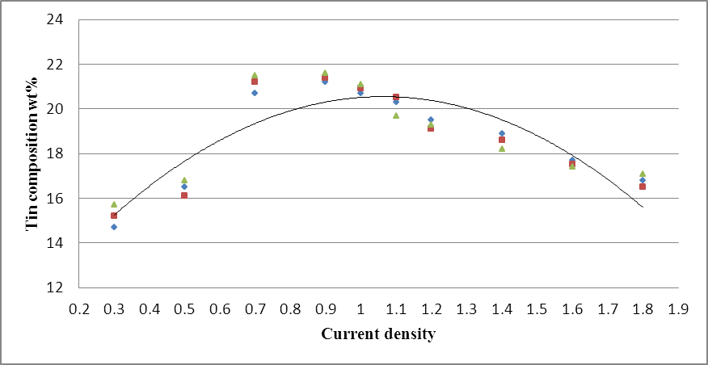
Fig.2 Effect of current density on deposit composition
Deposit appearance can be improved by controlling the stirring of machine as showed in Figure 3. The alloy surface is uneven with cloudy parts before improvement as Figure 3(a), and the appearance become even after adjustment as illustrated in Figure 3(b).
(a)
(b)
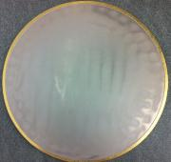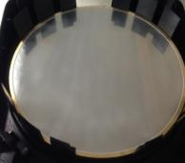
Fig.3 AuSn plating appearance after improvement by machine stirring

3.2 AuSn composition measurement
EDX is a promising quantitative analysis with accuracy of 1%. EDX is calibrated by an 80/20 wt% AuSn perform. The scan depth of SEM is controlled by acceleration voltage. Depth of 2um is scanned to measure AuSn composition from the top view.
Figure 4 shows the SEM plan view morphology of electroplated AuSn alloy and the corresponding EDX analysis result. The surface of the plating layer showed a homogenous grain structure. According to the EDX analysis result, the composition of the electroplated AuSn alloy was approximately Au80Sn20 by weight percentage.
To confirm EDX results, AuSn composition is also analyzed by Inductively Coupled Plasma with result Au80.43Sn19.57 by weight percentage.
A line scan of AuSn cross section is used to check uniformity the entire thickness as Figure 5. The scanned line is shown (Figure 5a), and the line scan graph indicate the measured composition from the surface into the bulk (Figure 5b).

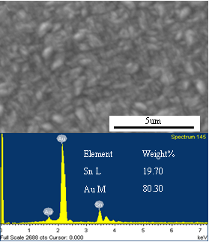
Fig.4 SEM plan view image and composition analysis

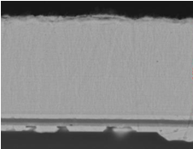
4um
Bulk
Surface
(a)
(b)
Scan direction
Fig. 5 EDX line scan analysis

3.3 Uniformity of surface composition and thickness
Surface composition and thickness were monitored from 9 locations per wafer and the results are highlighted in Figure 6.
Table 1 showed the variation of the gold composition and
alloy thickness within a wafer and between 18 wafers.

TABLE 1 Variation of Gold composition and alloy thickness
Items | Variation
Items | Within wafer | Between wafers
Gold composition | ±1.5% | ±3.3
Alloy thickness | ±4.2% | ±7.0 %

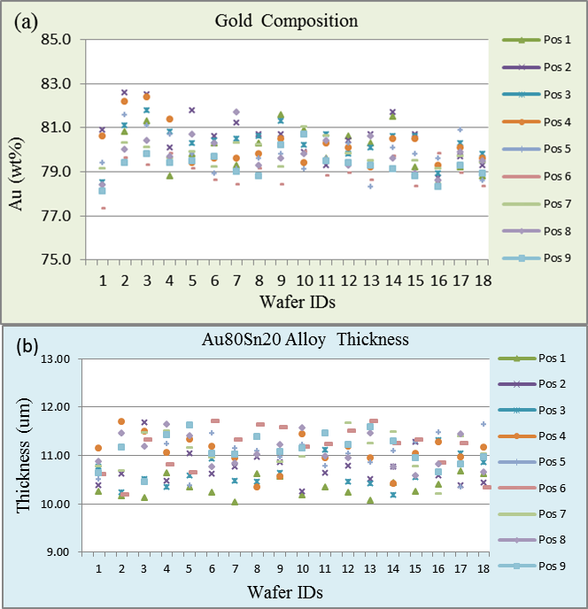
Fig.6 (a). AuSn composition uniformity; (b). AuSn alloy thickness distribution

3.4 AuSn uniformity analysis
Glow Discharge (GD) can be used on both conductive and non-conductive materials. This method ablates the metallization by glow discharge and the optical emission is measured by spectroscopy. Hence, even measurement of composition profiles is possible [7].
Here AuSn alloy uniformity was analyzed by GD. The relative measurement accuracy is 2% for the gold concentration and 15% for the depth information if appropriate calibration is used. A typical profile of plated AuSn is shown in Figure 7, and it shows a homogeneous composition in the bulk.
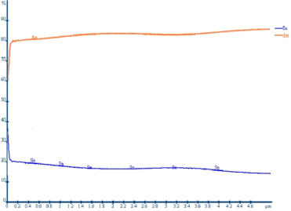
Fig.7 AuSn composition uniformity profile measured by GD

3.5 AuSn phase analysis
XRD uses x-ray beams to beat the surface of sample through incident beam optics, which will produce diffraction and superposition of the beams. The diffracted beams go into the generator to create the XRD spectrum.
From the phase diagram (Figure 1), AuSn eutectic alloy consists of the Au5Sn (ζ-phase) and AuSn (δ-phase) phases. Figure 8 shows the diffraction pattern of Au80Sn20 plated wafers. As expected [9], the alloy is a mixture of both AuSn and Au5Sn phases.

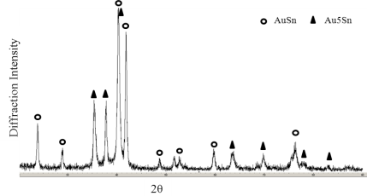
Fig.8 XRD patterns of plated Au80Sn20

3.5 Roughness measurement
Laser Microscope was used for measure AuSn surface roughness. Ra is 0.12um, and Figure 9 is the alloy appearance at 100 magnification.
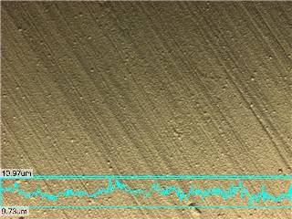
Fig.9 Surface roughness measured by laser microscope

3.6 Melting point measurement
Differential scanning calorimeter (DSC) is a thermal analysis technique. A sample of known mass is heated and the changes in its heat capacity are tracked as changes in the heat flow, which allows the detection melting point. AuSn alloy was taken by weight with 21.20mg, and test with temperature increasing speed 20.0 ˚C /min. A schematic DSC curve of AuSn shows as Figure 10 with expected melting point 278.5 ˚C and it will solidify at 277.7 ˚C.

Fig.10 Melting point measured by DSC

It was verified that the appropriate combination of these two phases (Au5Sn and AuSn) resulted in the eutectic composition of Au80Sn20 alloy with 278 ˚C melting point.

3.7 AuSn die attach stability
Dies were assembled via thermo-compression on flanges and robustness assessed by comparing product performance pre- & post- thermal cycling (target is 500 cycles from -65˚C to 150˚C [10]). Inspection after assembly showed wetting on the flange from the profile of solder fillet (flow-out). Assembled devices with AuSn plated dies show low Rth (thermal resistance). The integrity of the soldered interface (die-to-flange) was assessed via scanning acoustic microscopy (CSAM). As shown in Figure 11, no voids were detected. Both electrical and thermal performance was stable after 500cycles.
Fig.11 Scanning acoustic microscopy of soldered dies with AuSn

CONCLUSION
A technology of electronic plating of Au80Sn20 solder alloy has been developed and is introduced into volume production. The effect of deposit current density and machine stirring on electroplating deposit was studied. Alloy composition was maintained constant within the current density from 0.7 to 1.4. The even appearance can be controlled by the machine stirring.
Many methodologies were used for AuSn alloy characterization. Alloy bulk composition is uniform. The microstructure of the solder matrix was composed of eutectic phases of Au5Sn (ζ-phase) and AuSn (δ-phase). Alloy surface micro-roughness are benefit for solder die attach and hermetic sealing. The eutectic point is 278˚C，as same as the phase diagram [4]. AuSn BSM simplifies the die attach process – pick and place via thermo-compression. There is no change in the AuSn interface after 500cycles (-65˚C to 150˚C) due to the stability of both electrical and thermal performance of the device.

References

[1] Torleif A. Tollefsen, “Au-Sn SLID Bonding—Properties and
Possibilities,” Metallurgical and Materials Tranctions B, 2012, VOL 43B,
pp. 397-405
[2] Tao Zhou1, Tom Bobal, Martin Oud and Jia Songliang, “Au/Sn Solder
Alloy and Its Applications in Electronics Packaging,” unpublished
[3] George White, “High Temperature Electronics Packaging in Europe,”
pp.87-97
[4] H. Okamoto, “Journal of Phase Equilibria and Diffusion,” 2007, vol. 28
(5), p. 490.
[5] H.S. Liu, C.L. Liu, K. Ishida, and Z.P. Jin, “Thermody- namic Modeling of
the Au-In-Sn System,” Journal of Electronic Mater, 2003, vol. 32 (11), pp.
1290-1296.
[6] S. Weiss, V. Bader, G. Azdasht, P. Kassulke, E.Zakel, H. Reichl, “Fluxless
Die Bonding of High Power Laser Bars using AuSn-Metallurgy,” Proc.
Electronics Components and Technology Conference, San Jose, 1997, pp. 780-787
[7] Georg Greitmann, Hans Burkard, Josef Link, “AuSn Thin Film Solder
Layers for Assembly of Optoelectronic Devices,” 14th European
Microelectronics and Packaging Conference, 2003, pp.1-5
[8] L. Dietrich, M. Toepper, O. Ehrmann, H. Reichl, “Conformance of ECD
Wafer Bumping to Future Demands on CSP, 3D Integration, and MEMS,”
Electronic Components and Technology Conference, 2006, pp. 1050-1059.
[9] Jeong Won Yoon, Hyun Suk Chun, Ja Myeong Koo and Seung Boo Jung,
“AuSn Flip-Chip Solder Bump for Microelectronic and Optoelectronic
Applications,” 2006, pp. 26-28
[10] JESD22-A104D, “Temperature cycling”, JEDEC specification, 2009

